**National University Of Computer & Emerging Sciences Karachi Campus**



**Project Report**

**Computer Organization & Assembly Language**

**Section G**

**Group Members:**

**Syed Ahsan Akhtar Naqvi (19K-1475)**

**Muhammad Mustafa Bawany (19K-1273)**

**Ajar Sarmad (19K-1440)**

“Secure Encryption using RSA Algorithm”

* **INTRODUCTION**

An advanced encryption system (RSA) that incorporates a variety of encryption methods for increased security.

* **PROBLEM STATEMENT**

Encryption systems become more and more vulnerable the more widespread and well known they are. Furthermore, both encryption and decryption techniques are constantly advancing which means that encryption systems become outdated at a very rapid pace. This means that unique encryption methods which are consistently redeveloped with more and more advanced techniques are the need of the hour for reliable cyber security.

* **PROPOSED SOLUTION**

Application of modern encryption techniques with custom imposed variables to create a unique encryption which would be harder to decode due to randomness and use of layered encryption.

* **TOOLS AND TECHNOLOGIES**
* Programming Language: MASM x86
* IDE: Microsoft Visual Studio Code 2019 & Microsoft Visual Studio Code 2010
* **METHODOLOGY:**

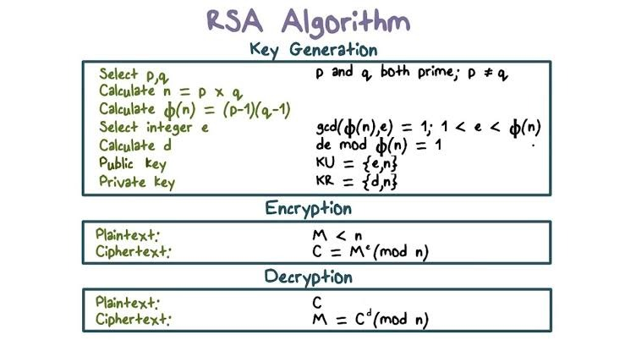

* 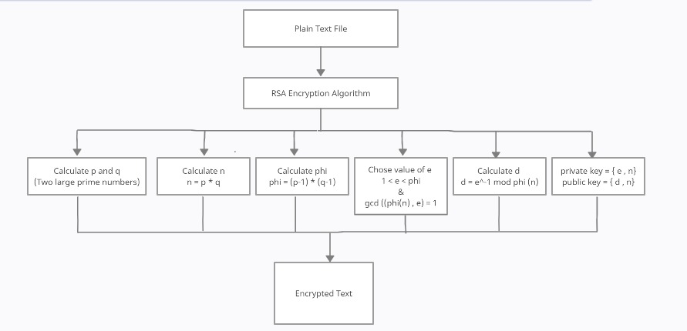**HIERARICHAL STRUCTURE**

***This hierarchical structure shows the general purpose of our system***

* **Working Model Snapshots**

Home Screen

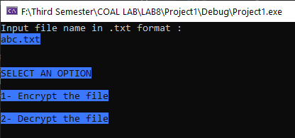

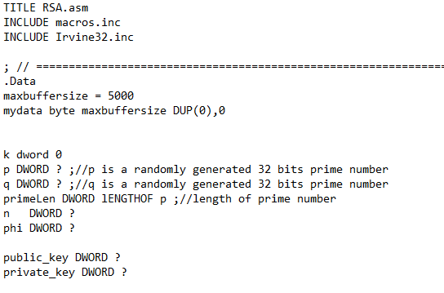

Plain text to be encrypted.

# **SWITCH (OPTION):**

# CASE 1: *ENCRYPT THE FILE*

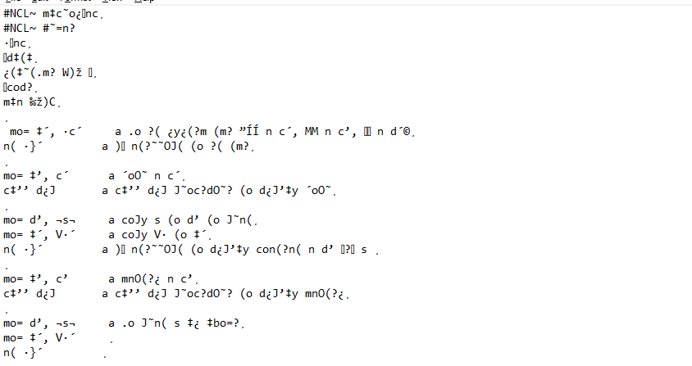

## *GENERATED KEYS:*

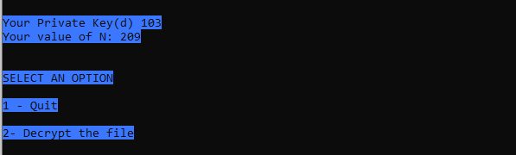

Options for decryption.

## **CASE 2: *DECRYPT THE FILE\***

**INPUT THE PRIVATE KEY AND VALUE OF N**

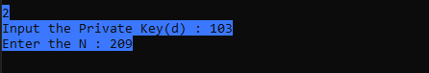

## **AFTER DECRYPTION:**



# **REFERENCES:**

<https://www.youtube.com/watch?v=C7gHx2StFi8>

<https://www.youtube.com/watch?v=nO7_qu2kd1Q>